**application Architecture**

**Functional requirements (required/desired)**

* Add task
* Delete task
* View task

**Non-functional requirements**

* Availability: anytime available to all users at localhost
* Usability: used by student, professor, Dean
* Security: user must login before use of this application

**System Architecture Diagram**

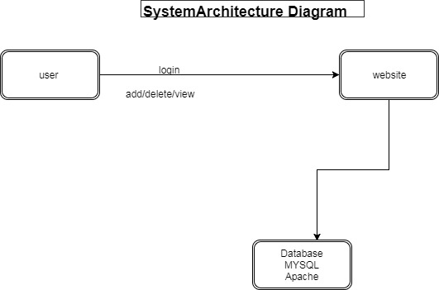

*Figure 1*

**Data Flow Diagram**

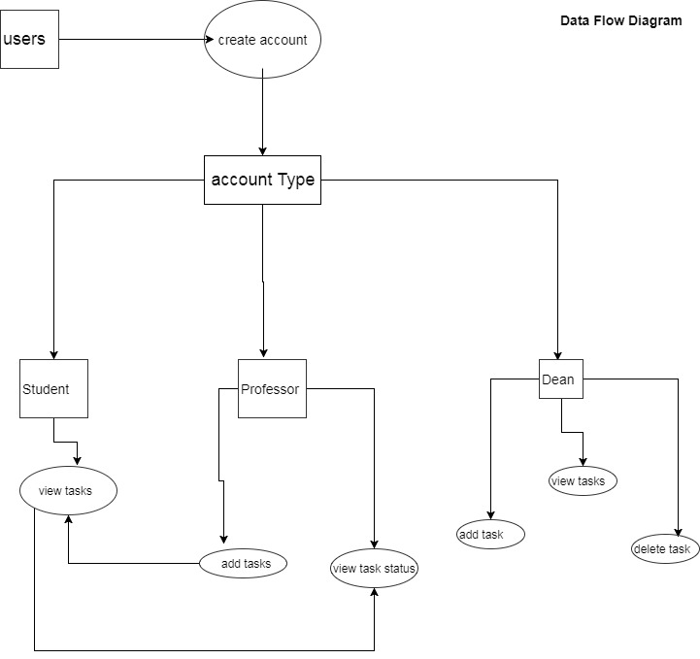

Figure 2

**Use case**

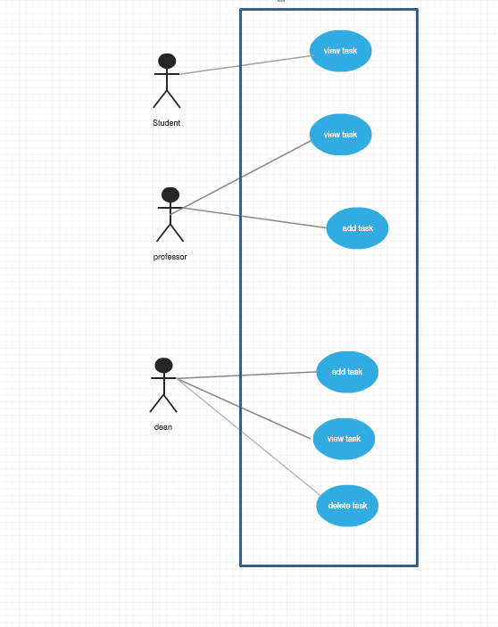

Figure 3 use case

**Sequence Diagram**

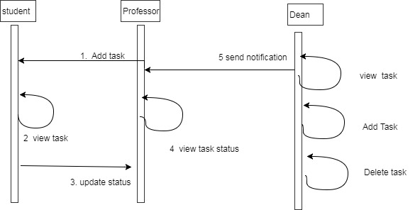

Figure 4 sequence diagram

**Database Design**

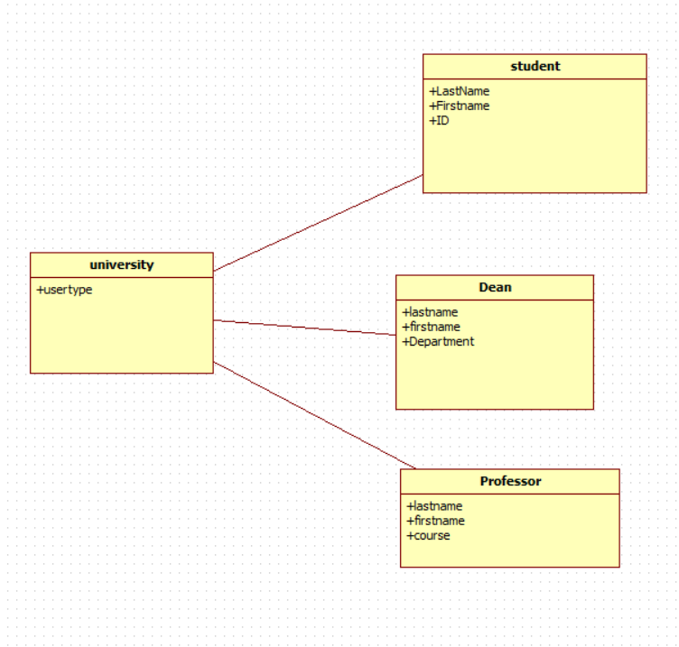

Figure 5

**Class diagram**

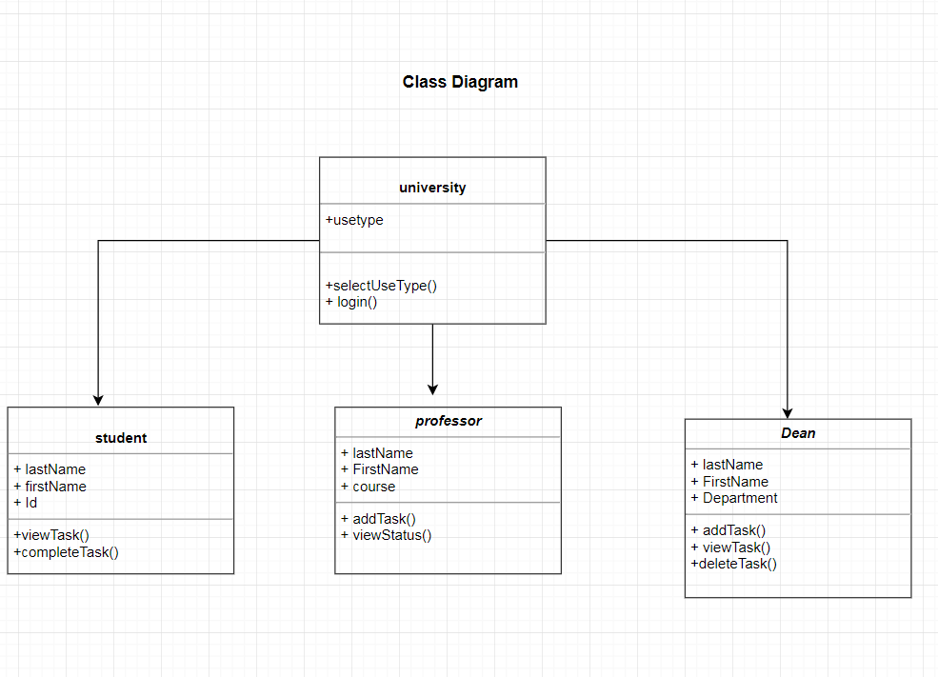

**Test Case**

* **User must be Student, professor or dean.**
* **Only professor and dean has ability to assign task.**
* **Student cannot delete task.**
* **Use cannot submit empty task.**